Coding – easy – Gatta Catch Em All

Problem: Find flag in the given text file

Hint: That’s a lot of lines, a script might be useful.

Given: given-easy.txt

Steps:

1) Notice that most the lines end in ==. This is a sign of base64.

Note: Base64 is an ASCII encoding scheme. The = at an end of a string is a good clue. To read more on base64 visit <https://en.wikipedia.org/wiki/Base64>.

2) Write a short python script to open the file and decode each line. Something similar to:

import base64

with open ("given-easy.txt", "r") as file1:

lines=file1.readlines()

with open (“output.txt”, “w”) as file2:

for i in lines:

file2.write(base64.b64decode(i)+”\n”)

Note: this short script will read in the given file into a list, then open a file called output and write the decoded text to the file. This code uses the base64 library which allows the base64.b64decode(string) and base64.b64encode(string). To learn more about this library visit <https://docs.python.org/2/library/base64.html>.

This is a screenshot of the output file after the text has been decoded. Notice the capital letters at each 8th line.

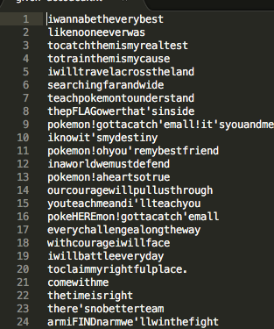

3) Solution:

8: thepFLAGowerthat'sinside

16: pokeHEREmon!gottacatch'emall

24: armiFINDnarmwe'llwinthefight

32: teacPATThpokemontounderstand

40: youtERNEeachmeandi'llteachyou

From these lines we can see a couple things going on, every 8 lines we are giving text we want and there are only 4 letters given at a time.

Let's make a python script to read this pattern through the entire file and see what we find. Something similar to this code:

with open ("output.txt","r") as file1:

listoftext=file1.readlines()

count=0

flag=""

for i in listoftext:

if ((count+1)%8)==0:

flag+=i[4:8]

count+=1

print flag

Note: this script goes through the list, keeps a counter of the line it is at which is actually (counter +1), since a list starts at 0 index and a file starts at like 1 there is an offset. Then you can mod this number by 8 to check if you are on one of the eighth lines. Then if the remainder is 0 take just the 4th to 8th character in the line. Again index starts at 0 but you want the 5 character until the 10th character but those are actually in locations 4 and 9 index.

This will give the following output:

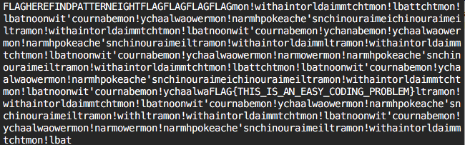

There is the flag:

FLAG{THIS_IS_AN_EASY_CODING_PROBLEM}

Example script:

import base64 #

with open ("given-easy.txt", "r") as file1:

lines=file1.readlines()

#with open("output.txt,"w") as file2: # STEP 1

# for i in lines: # for generating output file with

# file2.write(base64.b64decode(i) # readable text

listoftext=[] #

for i in lines: #

listoftext.append(base64.b64decode(i)) # list contains decoded text

count=0 #STEP 2

flag="" #this is the logic used to extract the

for i in listoftext: #flag from the file

if ((count+1)%8)==0: #

flag+=i[4:8] #

count+=1 #

print flag